QUESTION #1:

#include <math.h>
#include <stdio.h>
#include <string.h>
#include <stdlib.h>

int
main (void)
{
FILE*datax;

datax = fopen("data.txt" , "r"); /* reading from file */

double x[20]; /* defining variables */

int count;

double min;

double max ;

fscanf(datax, "%d %lf %lf", &count, &min, &max); /* recieving count, min, and max from file */

for (int c = 0; c<count; c++) { /* inserting all of the values in an array (excluding min, max, and count) */
fscanf(datax, "%lf", &x[c]);
}

double xhigh = x[0];

double xlow = x[0];

for (int i = 0; i<count; i++) { /* finding highest and lowest value */
if (x[i] > xhigh) {
xhigh = x[i];
}
}
for (int j = 0; j<count; j++) {
if (x[j] < xlow) {
xlow = x[j];
}
}

printf("Unormalized\t\tNormalized\n"); /* headings */
printf("___________\t\t__________\n");

for (int k = 0; k<count; k++) {
double normxi = min + (x[k] - xlow)*(max-min)/(xhigh-xlow); /* calculating normxi and printing */
printf("%.2f\t\t\t%.2lf\n", x[k], normxi);
}
}

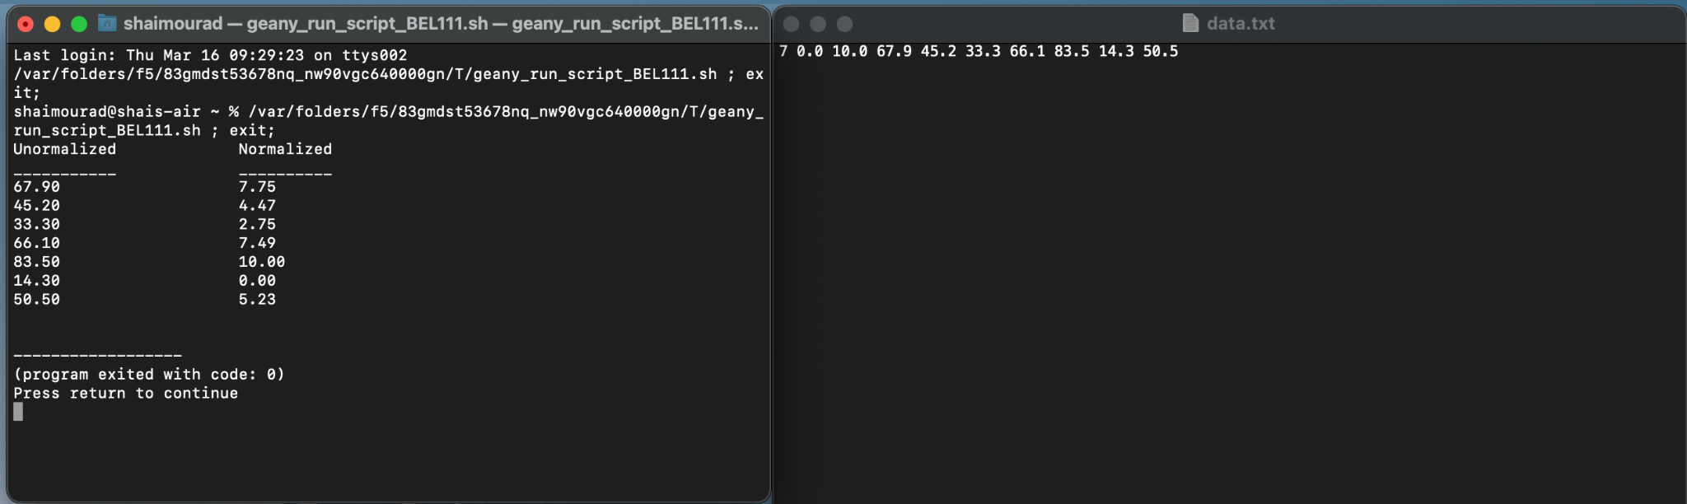

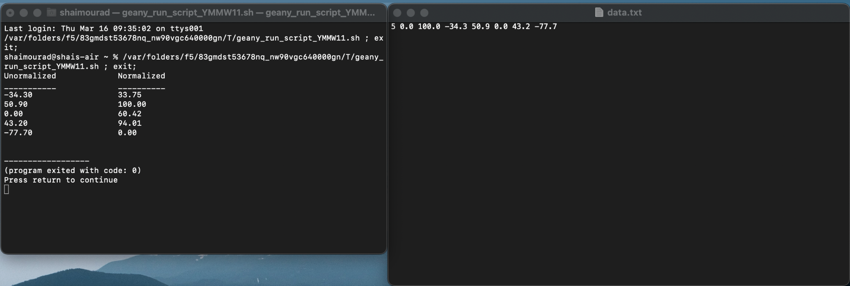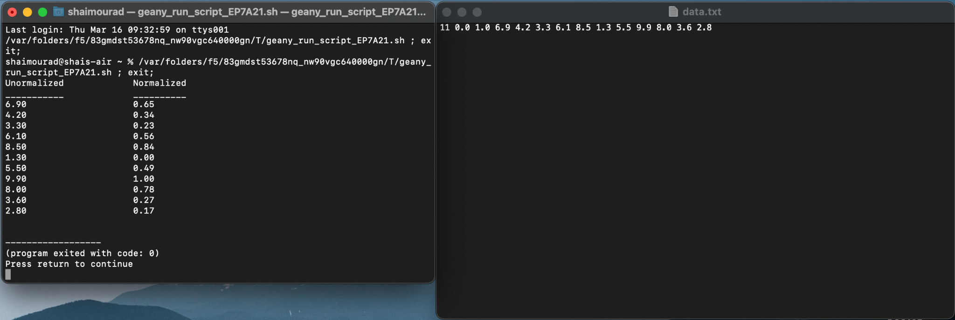

QUESTION #2:

#define ARRAY_SIZE 8

// finds the position of the smallest element in the subarray
// list[first] through list[last].
// Pre: first < last and elements 0 through last of array list are defined.
// Post: Returns the subscript k of the smallest element in the subarray;
// i.e., list[k] <= list[i] for all i in the subarray
int get_min_range (int list[], int first, int last)
{
int min_index = first;

for (int i = first+1; i<= last; i++) {
if (list[i] < list[min_index]) {
min_index = i;
}
}
return min_index;
}

// sorts the data in array list
void
select_sort(int list[], int n)
{
int fill, /* index of first element in unsorted subarray */
temp, /* temporary storage */
index_of_min; /* subscript of next smallest element */

for (fill = 0; fill < n-1; ++fill) {
/* Find position of smallest element in unsorted subarray */
index_of_min = get_min_range (list, fill, n-1);

/* Exchange elements at fill and index_of_min */
if (fill != index_of_min) {
temp = list[index_of_min];
list[index_of_min] = list[fill];
list[fill] = temp;
}
}
}

int
main (void) {
int array[] = {67, 98, 23, 11, 47, 13, 94, 58};
int i;

select_sort (array, ARRAY_SIZE);

for (i=0; i < 8; ++i)
printf ("%d ", array[i]);

return (0);
}

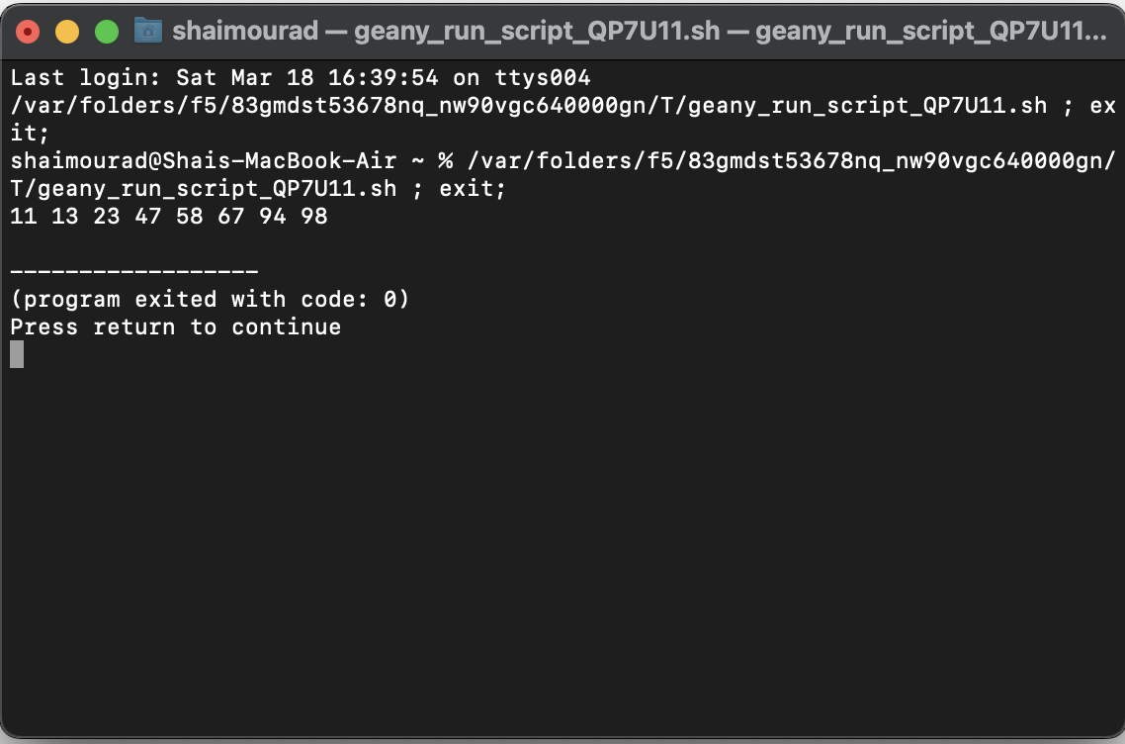

QUESTION #3:

#include <stdio.h>
#define STACK_EMPTY '0'
#define STACK_SIZE 20

void
push(char stack[], /* input/output - the stack */
char item, /* input - data being pushed onto the stack */
int *top, /* input/output - pointer to top of stack */
int max_size) /* input - maximum size of stack */
{
if (*top < max_size-1) {
++(*top);
stack[*top] = item;
}
}

char
pop (char stack[], /* input/output - the stack */
int *top) /* input/output - pointer to top of stack */
{
char item; /* value popped off the stack */

if (*top >= 0) {
item = stack[*top];
--(*top);
} else {
item = STACK_EMPTY;
}

return (item);
}

int
main (void)
{
char s [STACK_SIZE];
int s_top = -1; // stack is empty

push(s, 'A', &s_top, STACK_SIZE);
push(s, 'B', &s_top, STACK_SIZE);
push(s, 'C', &s_top, STACK_SIZE);

printf("current; ");

for (int i = 0; i <=s_top; i++) {
printf("%c ", s[i]);
}

char popped = pop(s, &s_top);
printf("\nPopped item: %c\n", popped);

for (int j = 0; j <=s_top; j++) {
printf("%c ", s[j]);
}
return (0);
}

